October 2022

Dear Friend,

Every year, members of the Howard Center community come together to help the people we serve meet their basic needs, enrich their lives, and brighten their seasonal celebrations with gifts to the Help is Here Client Funds. We hope you will join us in continuing this tradition by giving to the Help is Here Client Funds today.

Howard Center provides services to about 19,000 children, adults, and families each year, many of whom have very limited financial resources. This financial hardship can be especially detrimental because progress in addressing mental health, substance use, and developmental disabilities is enhanced when basic needs have been met and people have opportunities for personal enrichment. Thanks to the generous contributions from Howard Center donors and supporters such as yourself, last fiscal year we were able to provide over $31,000 in direct funding to more than 400 clients, supporting them to buy food, obtain basics like school supplies and clothing, and enabling them to participate in holiday observances, cultural activities, and educational opportunities that enrich their lives.

Donations may be made in the form of gift cards, by check, or online by clicking the “Donate” button at www.howardcenter.org. Gift cards are a wonderful way to give because of the independence they provide by enabling people to select and try on clothing and because they give parents the dignity and gratification that comes from shopping for their children. We ask for gift cards in denominations of $25 to vendors like Amazon, Walmart, Target, and Kohl’s, or to grocers like Shaw’s, Hannaford, and Price Chopper.

To contribute by mail, please complete the attached form and return it today along with your gift card(s) or contribution. Or give online at www.howardcenter.org (click the donate button and select “Holiday Giving/Client Needs” from the designation drop-down). If possible, please send your gift by November 30, so we have it in time to meet the many requests we receive as winter begins.

Thank you for being part of the Howard Center community and for supporting the people we serve.
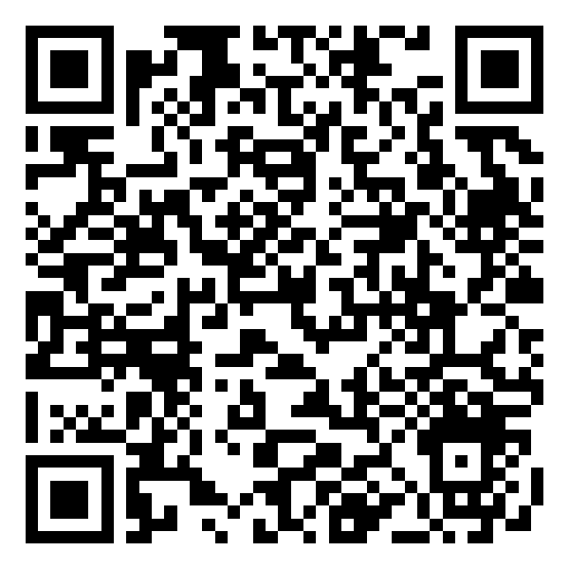
With our best wishes and thanks,
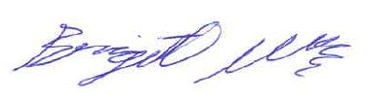
Scan this QR code or visit www.howardcenter.org to donate today!

Brigett Weinstein
Annual Fund and Events Manager
PS: We’ve enclosed an extra contribution form so you can pass it along to a friend or colleague. Please feel free to make copies of the form if you need more.

